APPLICATION AND SOLICITATION DISCLOSURE
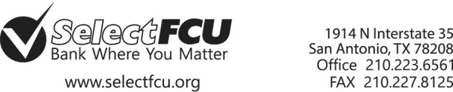

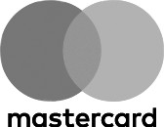

PLATINUM MASTERCARD

Interest Rates and Interest Charges
Annual Percentage Rate (APR) for  Purchases | 5.90% Introductory APR for a period of six billing cycles.  After that, your APR will be 9.90% to 14.75% , based on your creditworthiness.
APR for Balance Transfers | 5.90% Introductory APR for a period of six billing cycles.  After that, your APR will be 9.90% to 14.75% , based on your creditworthiness.
APR for Cash Advances | 5.90% Introductory APR for a period of six billing cycles.  After that, your APR will be 9.90% to 14.75% , based on your creditworthiness.
How to Avoid Paying Interest on  Purchases | Your due date is at least 25 days after the close of each billing cycle. We will not charge you any interest on purchases if you pay your entire balance by the due date each month.
For Credit Card Tips from the  Consumer Financial Protection Bureau | To learn more about factors to consider when applying for or using a credit card, visit the website of the Consumer Financial Protection Bureau at http://www.consumerfinance.gov/learnmore.
Fees
Transaction Fees  - Foreign Transaction Fee | 1.00% of each transaction in U.S. dollars
Penalty Fees  - Late Payment Fee  - Returned Payment Fee | Up to $25.00  Up to $25.00

How We Will Calculate Your Balance:
We use a method called "average daily balance (including new purchases)."

Promotional Period for Introductory APR:
The Introductory APR for purchases, balance transfers and cash advances will apply to transactions posted to your account during the first six months following the opening of your account. Any existing balances on Select Federal Credit Union loan or credit card accounts are not eligible for the Introductory APR for balance transfers.

Effective Date:
The information about the costs of the card described in this application is accurate as of: July 01, 2017
This information may have changed after that date. To find out what may have changed, contact the Credit Union.

For California Borrowers, the Platinum MasterCard is a secured credit card. Credit extended under this credit card account is secured by various personal property and money including, but not limited to: (a) any goods yo u purchase with this account, (b) any shares you specifically pledge as collateral for this account on a separate Pledge of Shares, (c) all shares you have in any individual or joint account with the Credit Union excluding shares in an Individual Retirement Account or in any other account that would lose special tax treatment under state or federal law, and (d) collateral securing other loans you have with the Credit Union excluding dwellings. Notwithstanding the foregoing, you acknowledge and agree that during any periods when you are a covered

SEE NEXT PAGE for more important information about your account.

borrower under the Military Lending Act your credit card will be secured by any specific Pledge of Shares you grant us but will not be secured by all shares you have in any individual or joint account with the Credit Union. For clarity, you will not be deemed a covered borrower if: (i) you establish your credit card account when you are not a covered borrower; or (ii) you cease to be a covered borrower.

Other Fees & Disclosures:
Late Payment Fee:
$25.00 or the amount of the required minimum payment, whichever is less, if you are 10 or more days late in making a payment.

Returned Payment Fee:
$25.00 or the amount of the required minimum payment, whichever is less.

Mastercard and the Mastercard Brand Mark are registered trademarks of Mastercard International Incorporated.

