GAP

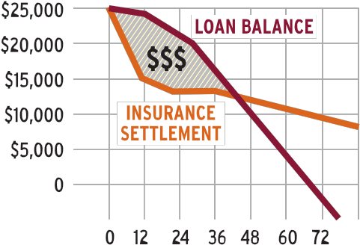

PLUS
Will you owe more on your vehicle
loan than your vehicle is worth?

A wrecked vehicle can wreck your finances if you owe more on your loan than your insurance will pay.
GAP Plus is like an airbag for your vehicle loan.
Guaranteed Asset Protection (GAP) Plus can help fill the gap between what your vehicle insurance will pay and what you owe on your loan, to cushion you against sudden out of pocket expenses if your vehicle is deemed a total loss. GAP Plus may cancel part of your next loan with your credit union, when you purchase a replacement vehicle. GAP Plus can help lighten the financial burden for you and the people you care about.

Fair market insurance value isn’t always fair. There may be a GAP.

The second you drive your new vehicle off
the lot it drops in value. Up to 22% in one year.1
This creates a gap in
coverage.

Talk to your loan officer to purchase GAP Plus today.

1 % for a typical vehicle in America. Edmunds, “How long should my vehicle loan be?”, http://www.edmunds.com/ vehicle-loan/how-long-should-my-vehicle-loan-be. html March 2015.
Your purchase of MEMBER’S CHOICETM Guaranteed Asset Protection (GAP) is optional and will not affect your appli- cation for credit or the terms of any credit agreement you have with us. Certain eligibility requirements, conditions, and exclusions may apply. You will receive the contract be- fore you are required to pay for GAP. You should carefully read the contract for a full explanation of the terms. If you choose GAP, adding the GAP fee to your loan amount will increase the cost of GAP. You may cancel GAP at any time. If you cancel GAP within 90 days you will receive a full refund of any fee paid.
GAP purchased from state chartered credit unions in FL, GA, IA, RI, UT, VT, and WI, may be with or without a refund provision. Prices of the refundable and non- refundable products are likely to differ. If you choose a refundable product, you may cancel at any time during the loan and receive a refund of the unearned fee.
GAP purchased from state chartered credit unions in CO, MO, or SC may be canceled at any time during the loan and receive a refund of the unearned fee. GAP-1497980.1-0516-0618 ©2017 CUNA Mutual Group, All Rights Reserved.

